Submitting a VistA/CPRS Request through YourIT
Before Submitting:
First, determine whether this is a Change Request or an Incident:
- Change requests are tickets submitted to the Health Informatics team for assistance creating or modifying items in VistA/CPRS such as note titles/templates, consults, orders, etc.
- Incidents are tickets submitted when something is NOT working correctly. These tickets are reviewed by OIT first and routed to Health Informatics if appropriate.
Then, determine whether you need help from Informatics or not:
- If yes, submit a ticket and request help in the free text field for request description (see instructions below)
- If no, fill out the appropriate request approval form
  - Consult request approval form: Linking coming soon
  - Note title/template approval form: Link coming soon
  - Orders/Misc: add a click hyper link - Please use an email from your Service Chief approving the request
Step-by-Step:

- Enter the VistA/CPRS Request - yourIT Service Portal (va.gov)
- Enter your details:
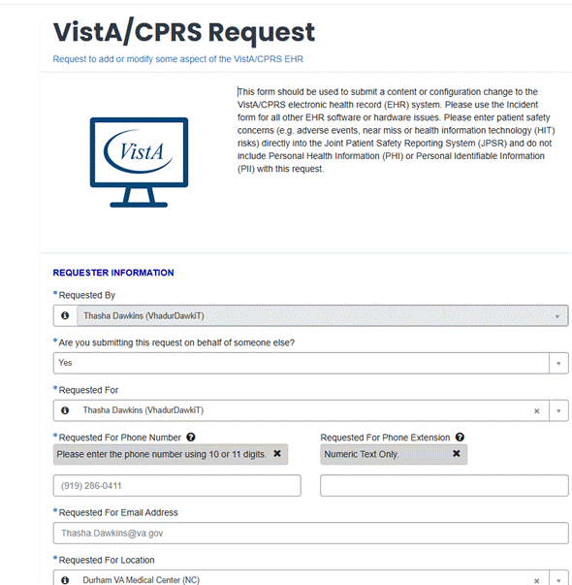

- Click "Standard Content and Configuration Change"
See above for definition of difference between "Incident" and "Change"
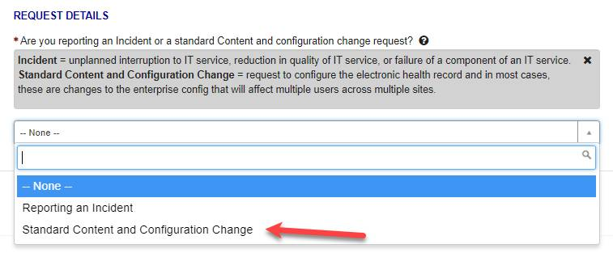
- Type in "Durham" to choose Durham VAHCS as the site
- Choose "No" unless HTM is involved, then choose "Yes"
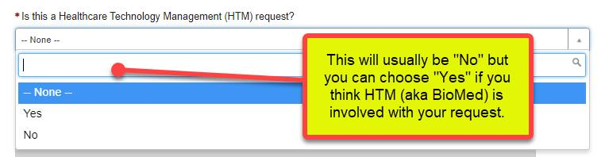
- Enter Yes/No for whether this is related to a Patient Safety
- If the response is "Yes," file a JPSR first and then include the JPSR number

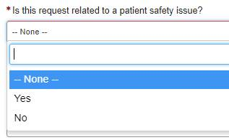
- Enter basic info to describe your request
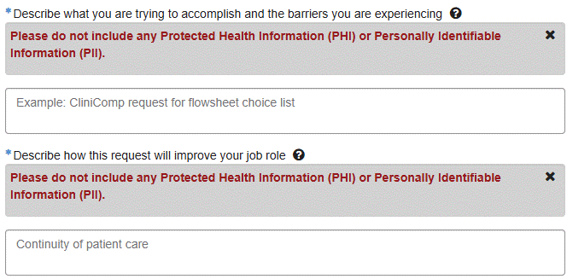
- Choose the appropriate service and application, which will usually be VistA/CPRS
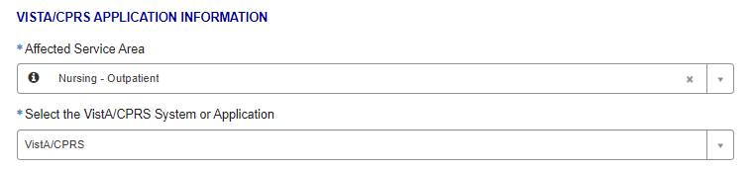
- Choose appropriate type of request
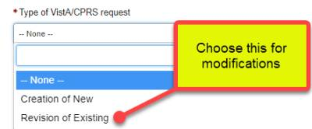
- Choose the specific type of VistA/CPRS request such as CliniComp, iMed Consent, CPRS Consult, CPRS Template, etc..
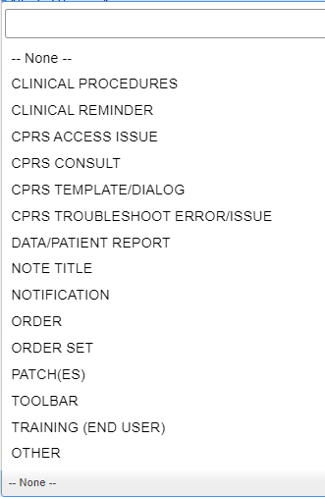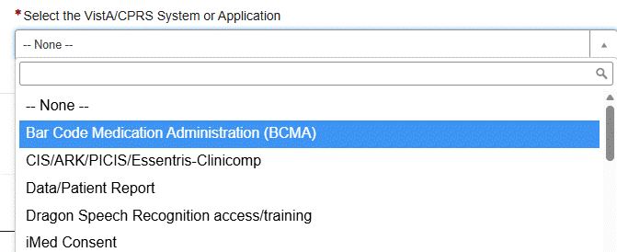
- Choose appropriate request reason
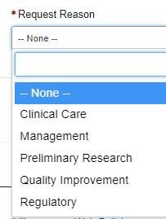
- Click "Add attachments" to attach documents, completed forms, and etc.

You may add PHI/PII" to tickets (VIA ATTACHMENTS ONLY) if they are encrypted.
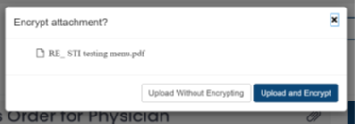

- Click "Order Now" to submit your request


